25.56: a) 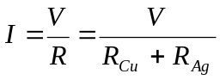
and
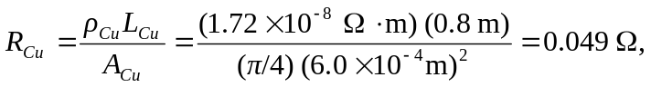
and
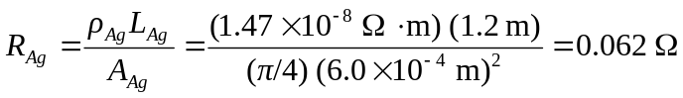
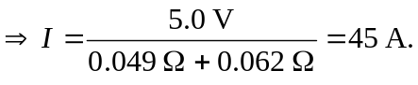
So the current in the copper wire is 45 A.
b) The current in the silver wire is 45 A, the same as that in the copper wire or else charge would build up at their interface.
c) 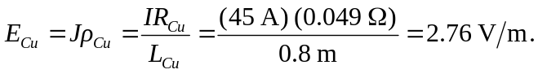
d) 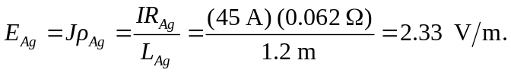
e)

